1. **Mockup for new sync option**

This is current menu of application

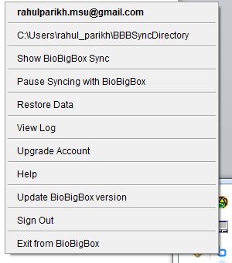

**Changes Required**

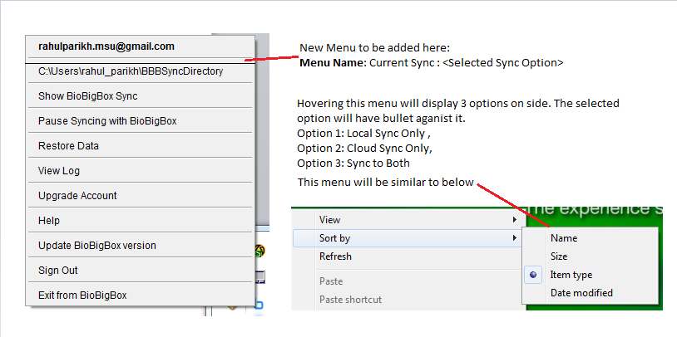

1. **Mock for restore from**

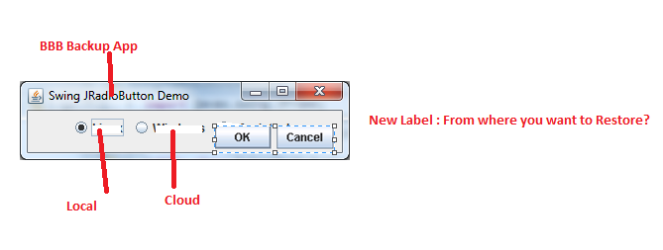

1. **Mock up for Restore**

Current Restore Window

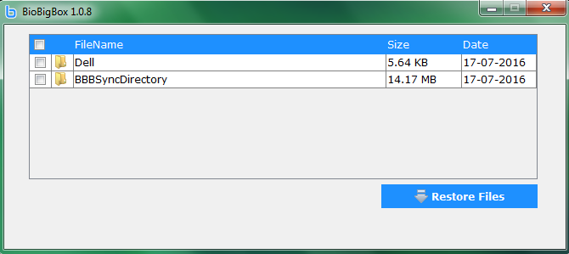

Whenever we double click on the folder, below screen will come which will contains list of files

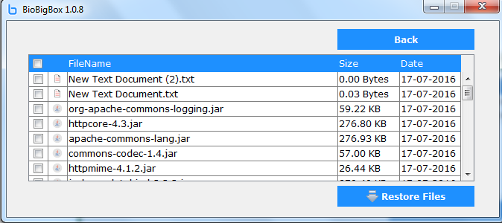

**New Changes to make in above screen**.

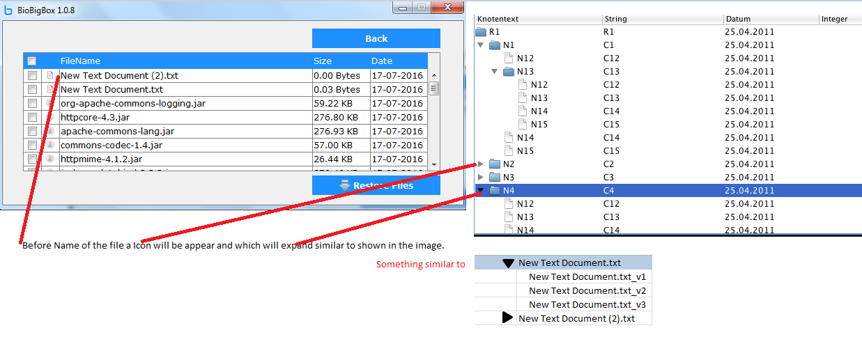

1. **Mock up for Selecting External Hard Disk**

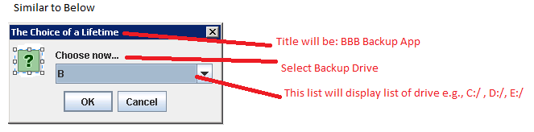

1. **Mock up for changing destination Drive**

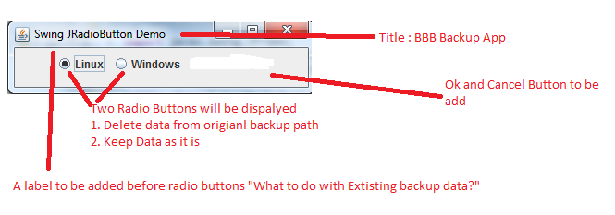

1. **Mock Up after selecting Delete Data from original backup path**

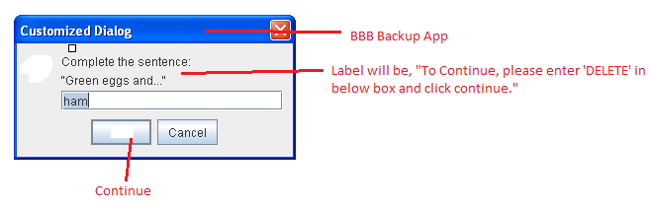

1. **Mockup after pressing Continue**

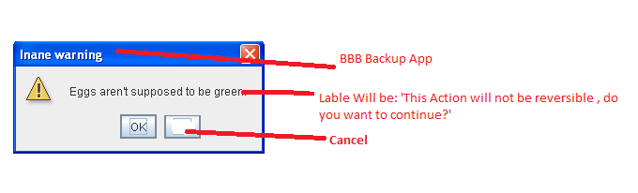

1. **Mockup Document Versioning Configuration**

